**4. House Number** 4 from the excel table

Sofia, 36, Yaroslav Hashek Str.,regionPoduene

GPS N 42º42’31.3” and E 23º23’19.5”The house is with 2 floors without basement.

3 MDC – yellow; 3 MCH – black and 2 CATS

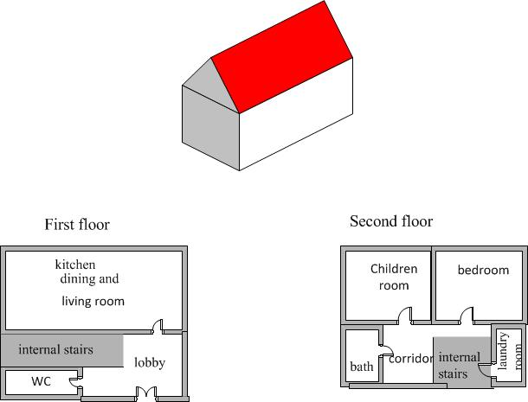

pair of CATS

relevant GTS

E-perm